Create a basic CRUD website with Symfony 4.2 and some command line helpers

First download symfony CLI from <https://symfony.com/download>

After that you can use the “**symfony**” command to create project

Create new symfony project:

|  |
| --- |
| symfony new --full --version=4.2 basic_crud |

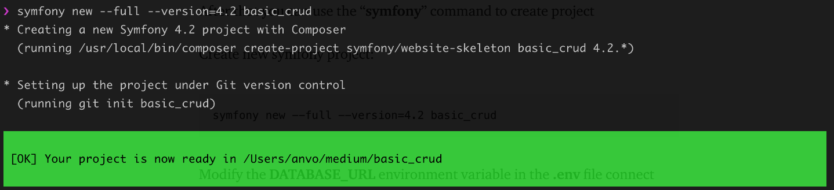

Go to the project folder

|  |
| --- |
| cd basic_crud |

Modify the **DATABASE_URL** environment variable in the **.env** file connect with your database, for example if you use localhost mysql with username **root**, password **empty**, database name **basic_crud_db**

|  |
| --- |
| DATABASE_URL=mysql://root:@127.0.0.1:3306/basic_crud_db?serverVersion=mariadb-10.4.11 |

You can create the database directly in your database client interface, or create by Symfony command line:

|  |
| --- |
| php bin/console doctrine:database:create |

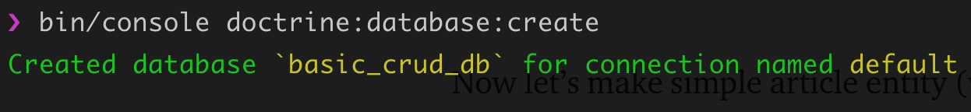

Now let’s make simple article entity (with the “name” property)

|  |
| --- |
| php bin/console make:entity |

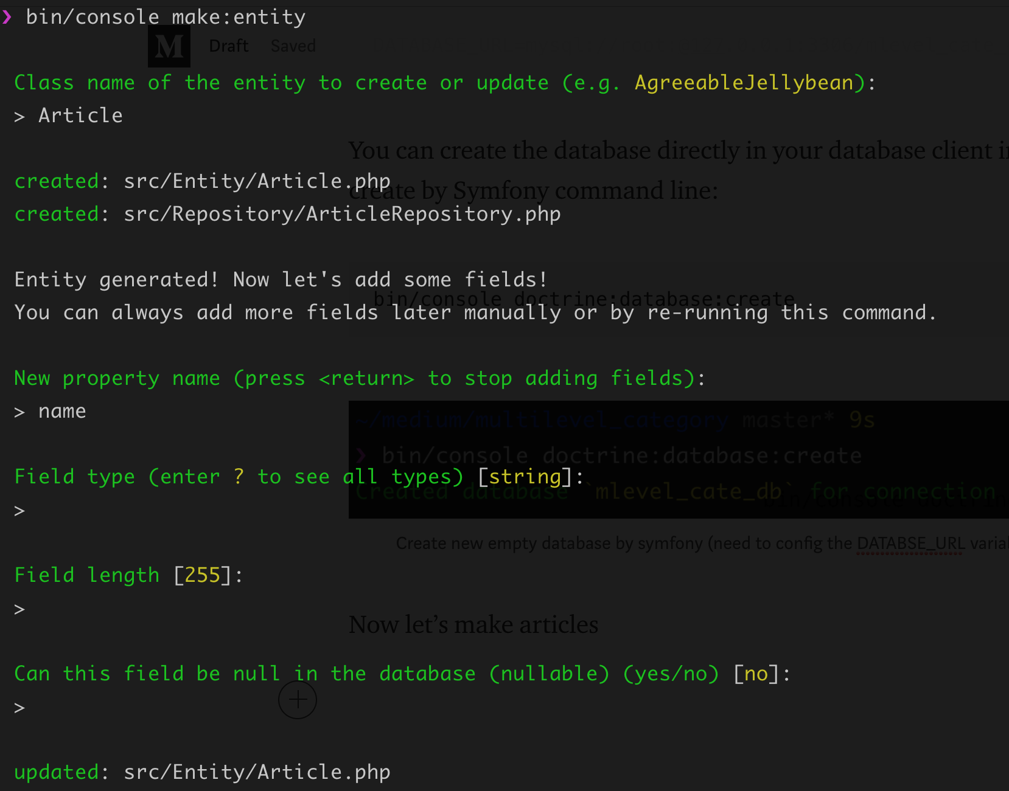

Create a migration file

|  |
| --- |
| bin/console make:migration |

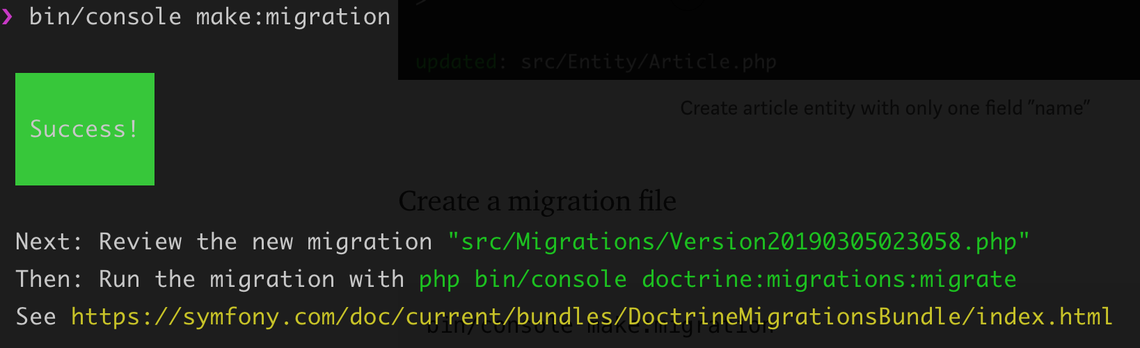

The make:migration will create an instruction file contain SQL query

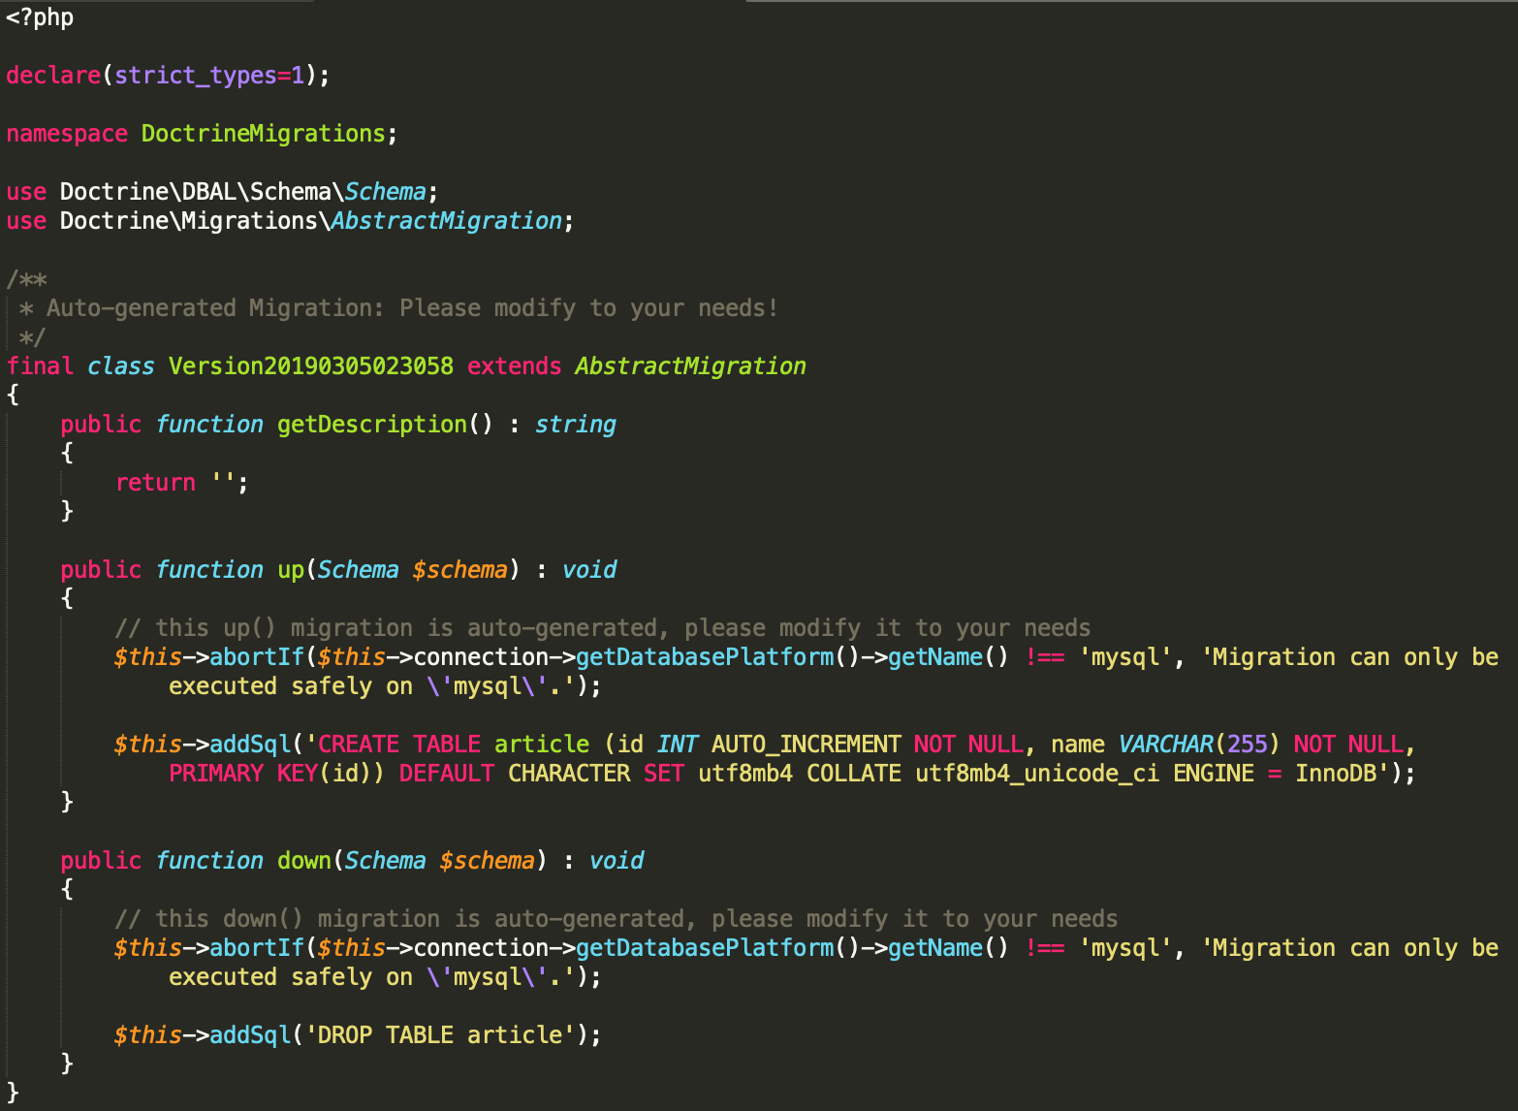

In order to create the table, run following command

|  |
| --- |
| php bin/console doctrine:migrations:migrate |

Now new table “article” already been created in our *basic_crud_db* database

Let’s insert some mock data (via coding)

First install fixture which help to insert database record by symfony code

|  |
| --- |
| composer require orm-fixtures --dev |

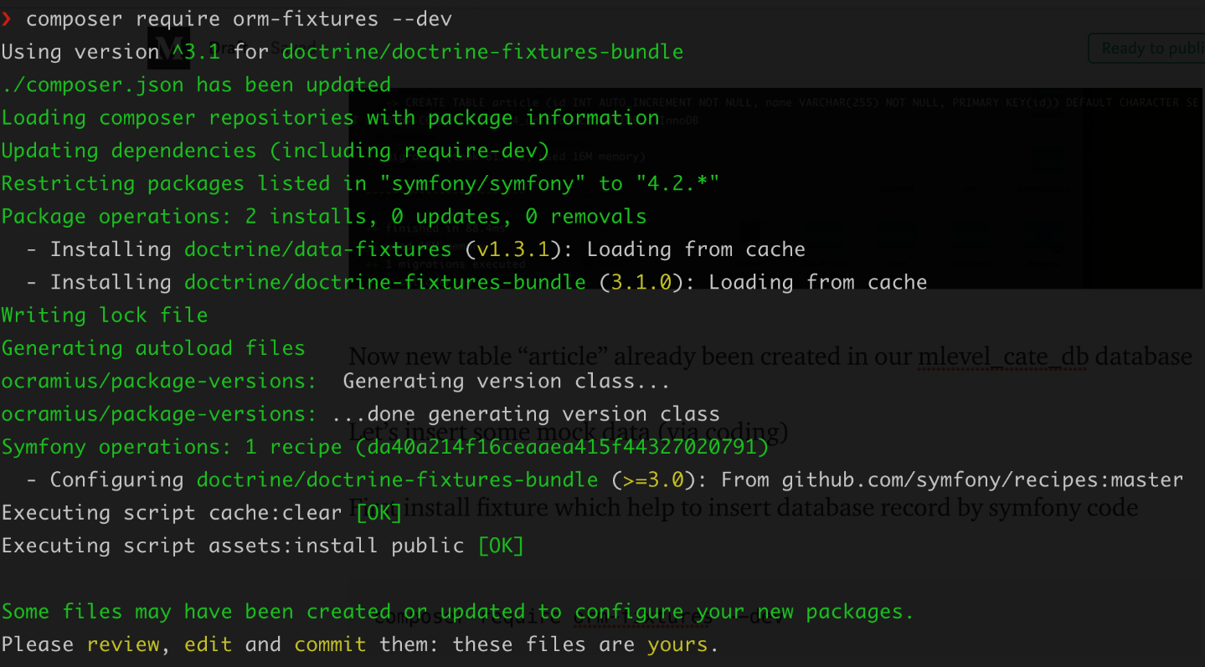

It’s time to make a fixture

|  |
| --- |
| php bin/console make:fixtures |

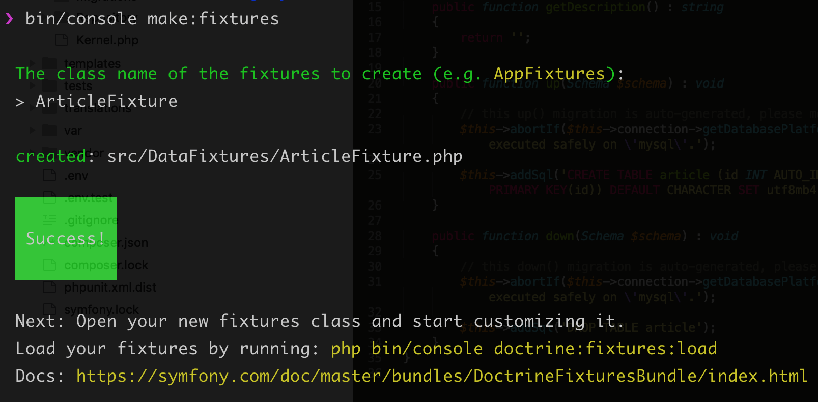

Now open the fixture file at /src/DataFixtures/ArticleFixture.php and add some code to create 10 articles

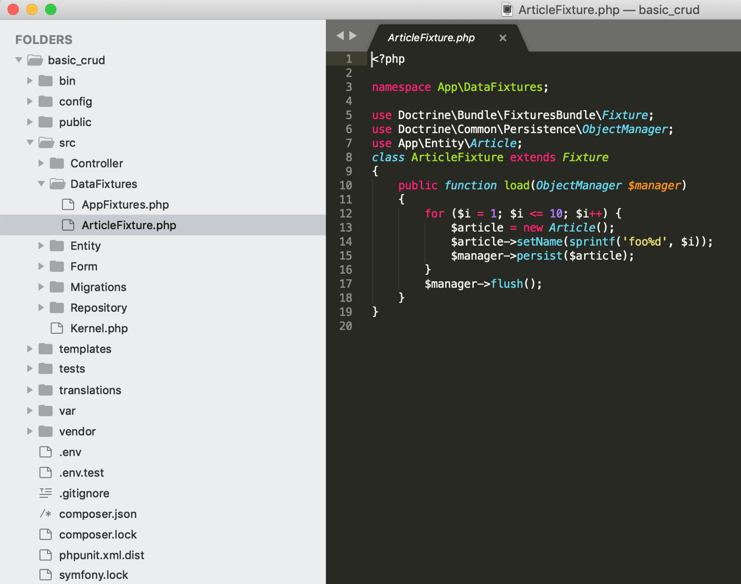

Run the file to insert records into database

|  |
| --- |
| bin/console doctrine:fixtures:load |

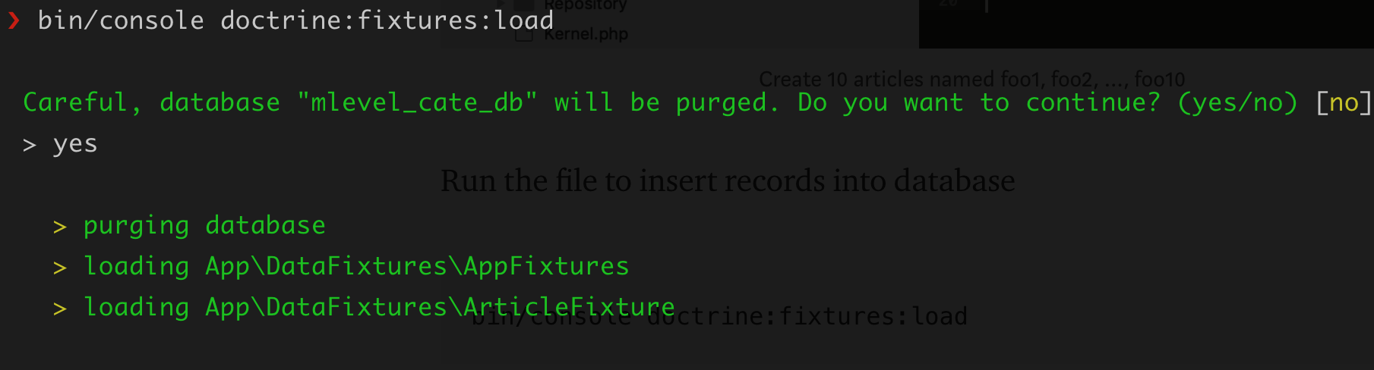

Now 10 article records already inserted into database, we can check it by the command:

|  |
| --- |
| php bin/console doctrine:query:sql "select * from article" |

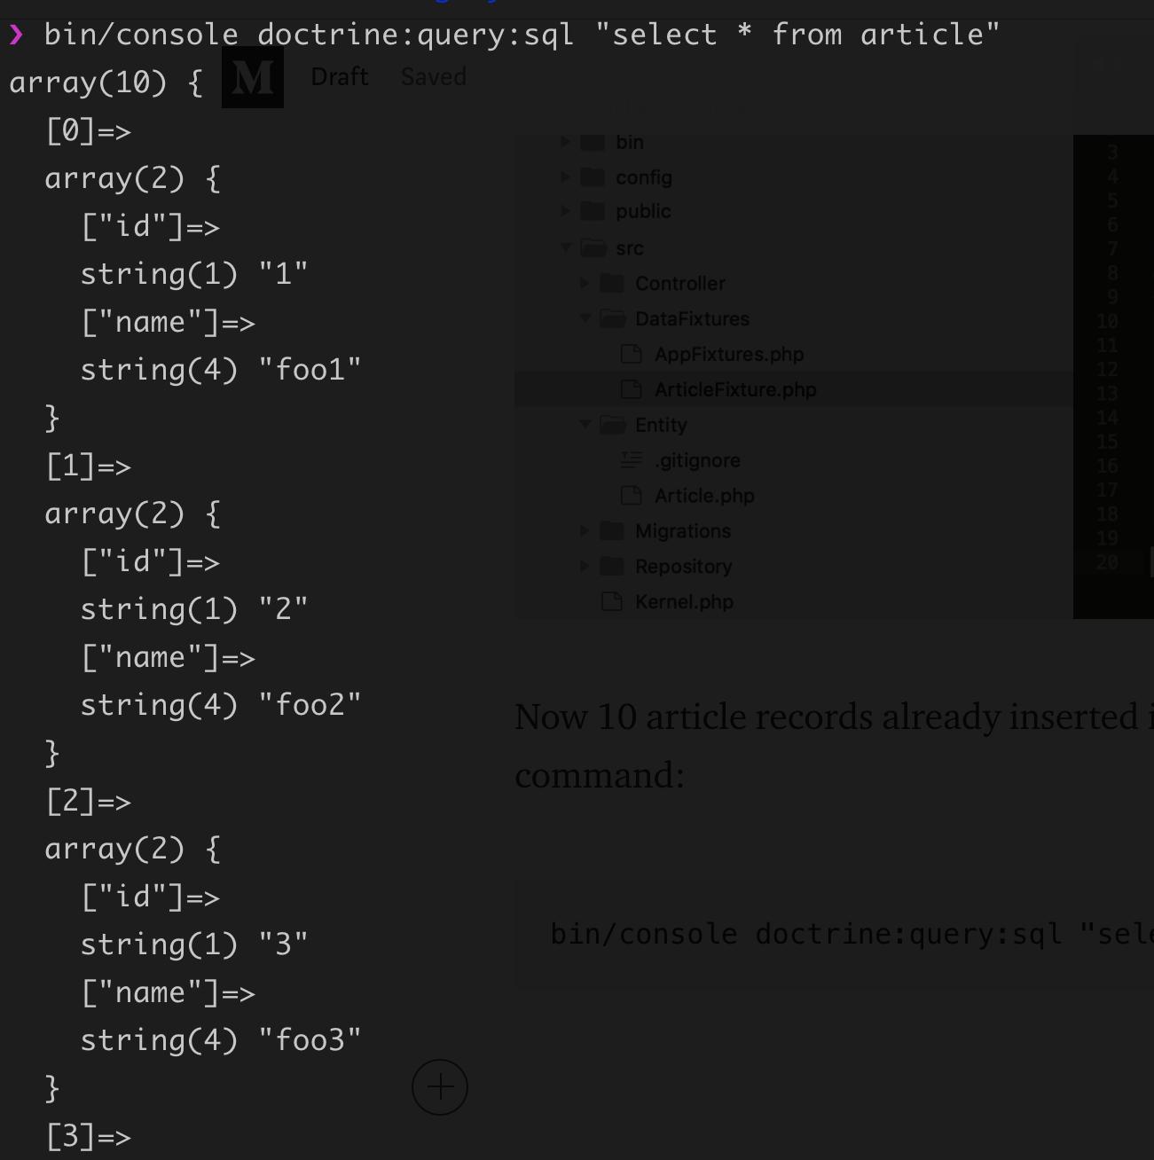

Time to make the view & controller

|  |
| --- |
| php bin/console make:crud |

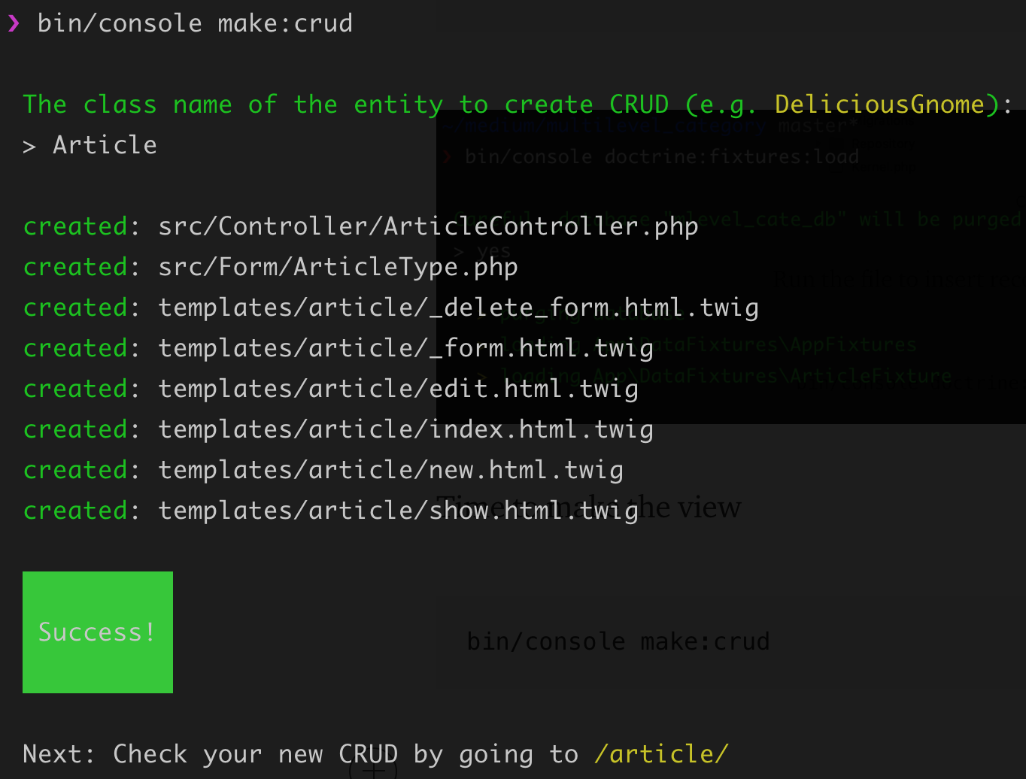

Now run the localhost website:

php bin/console server:run

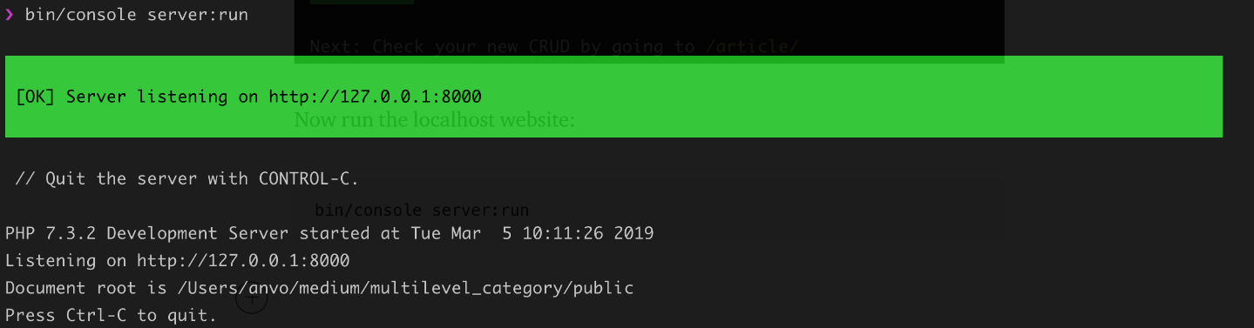

We are done

